Project Design Phase
Problem – Solution Fit Template

Date | 08/02/2026
Team ID | LTVIP2026TMIDS83275
Project Name | Deep Learning Fundus Image Analysis for Early Detection of Diabetic Retinopathy
Maximum Marks | 2 Marks

Problem – Solution Fit Template:

• Solving Complex Problems:
This deep learning system addresses the high-variability and expertise-dependent nature of diabetic retinopathy diagnosis by transforming complex retinal image patterns into structured, data-driven severity predictions. It reduces diagnostic subjectivity and converts visual medical "noise" into accurate, automated classification results suitable for screening environments.

• Increasing Solution Adoption:
By integrating into existing hospital workflows and digital screening systems, the model works with standard fundus image formats (.jpg, .png) captured through retinal cameras. The web-based interface ensures that healthcare professionals can use the tool without learning new complex systems, making adoption seamless and non-disruptive.

• Sharpening Communication:
The system identifies critical healthcare triggers — such as routine diabetic checkups, vision complaints, or community screening camps — to provide early risk detection feedback. It shifts stakeholders from a state of uncertainty and delayed diagnosis to timely awareness and proactive treatment planning.

• Increasing Touch-points & Building Trust:
By solving the frequent problem of delayed diagnosis and human error in manual screening, the model enhances trust through consistent prediction accuracy and quick turnaround time. Over time, repeated reliable results increase confidence among healthcare providers and patients.

• Improving the Existing Situation:
The system moves the screening process from purely specialist-dependent evaluation toward an AI-assisted, scalable healthcare solution. It supports inclusive medical access, especially in rural or under-resourced areas where ophthalmologists are limited, enabling early intervention and reducing preventable blindness.

Template:
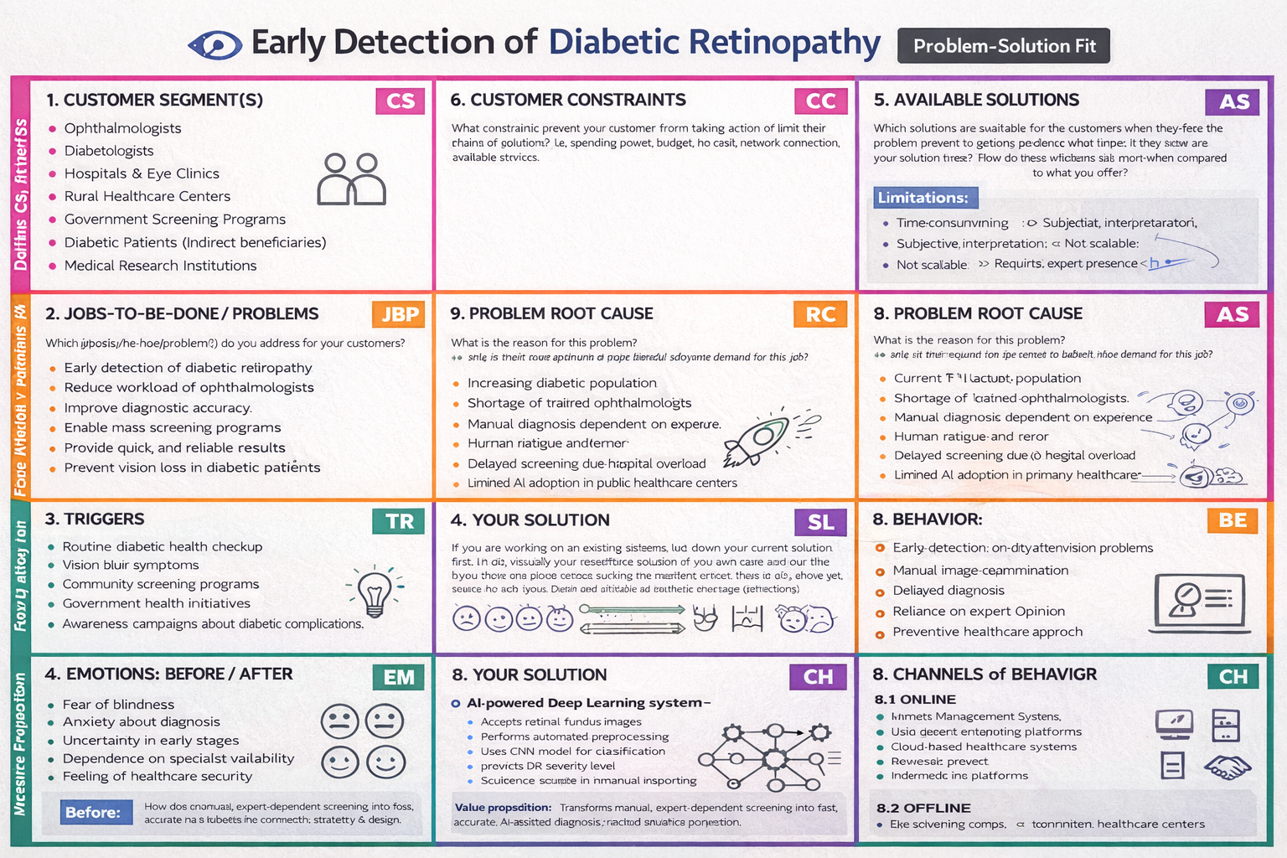
References:
- https://www.ideahackers.network/problem-solution-fit-canvas/
- https://medium.com/@epicantus/problem-solution-fit-canvas-aa3dd59cb4fe

